**Project Development Phase**

**Delivery of Sprint - 3**

|  |  |
| --- | --- |
| **Date** | 07 November 2022 |
| **Team ID** | PNT2022TMID45108 |
| **Project Name** | AI-based discourse for Banking Industry |

**Creating Loan Account Action**

Loan

action

is

created

with

the

necessary

steps.

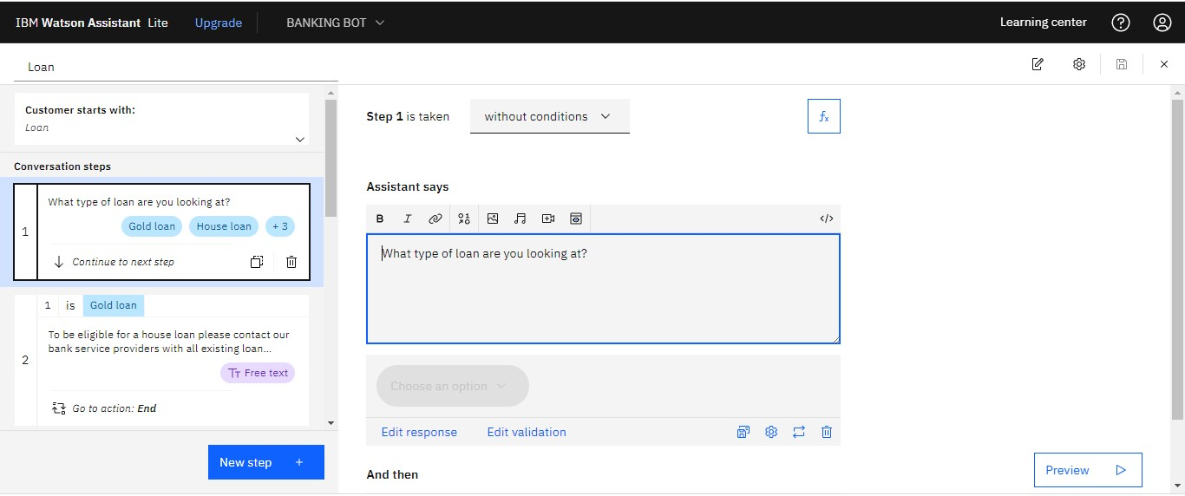

**Creating General Query Action**

General

query action

is

created

with

the

necessary

steps.

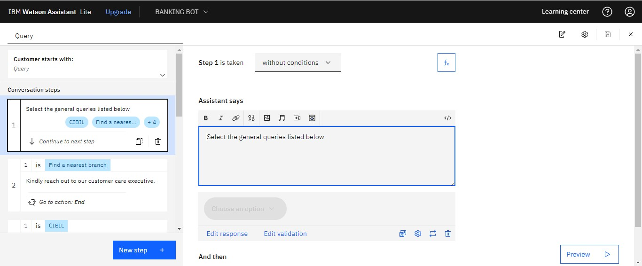

**Creating Net Banking Action**

Net banking action is created with the necessary steps.

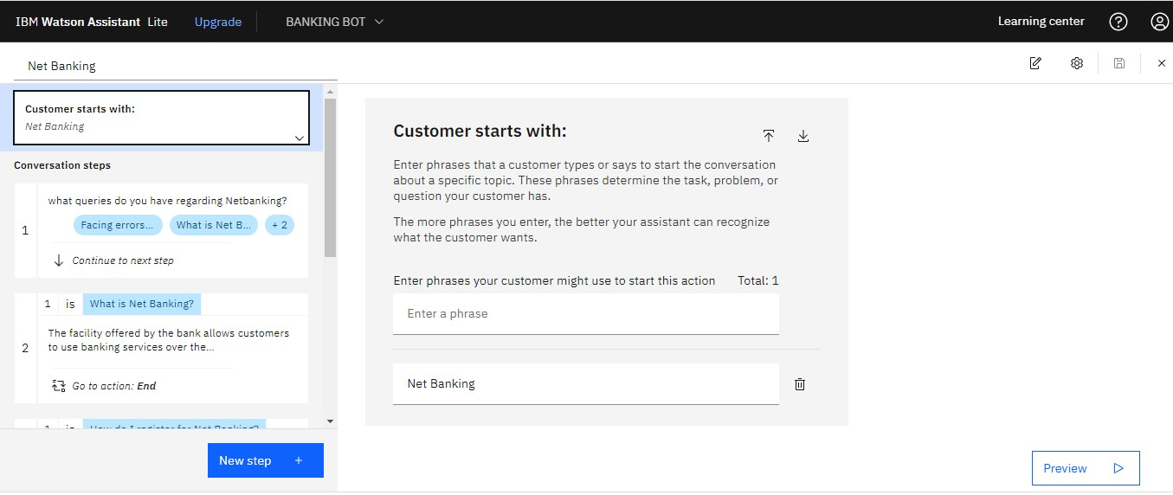

In addition to this greeting, end greeting ,index and end actions are also created.

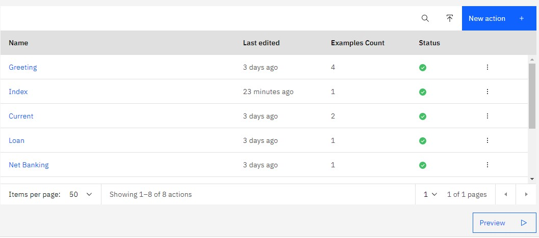

**PREVIEW**

**OF**

**CHATBOT:**

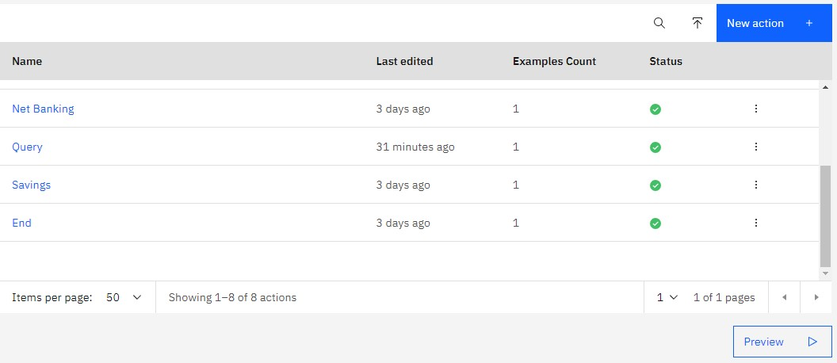

[**https://web-**](https://web-chat.global.assistant.watson.appdomain.cloud/preview.html?backgroundImageURL=https%3A%2F%2Fus-south.assistant.watson.cloud.ibm.com%2Fpublic%2Fimages%2Fupx-35339789-38d5-451f-8f05-3ddb5dbbe57e%3A%3A49d7f8d1-0500-4610-9518-068ec885f252&integrationID=fc789460-2e93-472d-b324-c85bef5219f5&region=us-south&serviceInstanceID=35339789-38d5-451f-8f05-3ddb5dbbe57e)

[**chat.global.assistant.watson.appdomain.cloud/preview.html?backgroundImageU RL=https%3A%2F%2Fus-**](https://web-chat.global.assistant.watson.appdomain.cloud/preview.html?backgroundImageURL=https%3A%2F%2Fus-south.assistant.watson.cloud.ibm.com%2Fpublic%2Fimages%2Fupx-35339789-38d5-451f-8f05-3ddb5dbbe57e%3A%3A49d7f8d1-0500-4610-9518-068ec885f252&integrationID=fc789460-2e93-472d-b324-c85bef5219f5&region=us-south&serviceInstanceID=35339789-38d5-451f-8f05-3ddb5dbbe57e)

[**south.assistant.watson.cloud.ibm.com%2Fpublic%2Fimages%2Fupx-35339789-**](https://web-chat.global.assistant.watson.appdomain.cloud/preview.html?backgroundImageURL=https%3A%2F%2Fus-south.assistant.watson.cloud.ibm.com%2Fpublic%2Fimages%2Fupx-35339789-38d5-451f-8f05-3ddb5dbbe57e%3A%3A49d7f8d1-0500-4610-9518-068ec885f252&integrationID=fc789460-2e93-472d-b324-c85bef5219f5&region=us-south&serviceInstanceID=35339789-38d5-451f-8f05-3ddb5dbbe57e)

[**38d5-451f-8f05-3ddb5dbbe57e%3A%3A49d7f8d1-0500-4610-9518-**](https://web-chat.global.assistant.watson.appdomain.cloud/preview.html?backgroundImageURL=https%3A%2F%2Fus-south.assistant.watson.cloud.ibm.com%2Fpublic%2Fimages%2Fupx-35339789-38d5-451f-8f05-3ddb5dbbe57e%3A%3A49d7f8d1-0500-4610-9518-068ec885f252&integrationID=fc789460-2e93-472d-b324-c85bef5219f5&region=us-south&serviceInstanceID=35339789-38d5-451f-8f05-3ddb5dbbe57e)

[**068ec885f252&integrationID=fc789460-2e93-472d-b324-c85bef5219f5&region=ussouth&serviceInstanceID=35339789-38d5-451f-8f05-3ddb5dbbe57e**](https://web-chat.global.assistant.watson.appdomain.cloud/preview.html?backgroundImageURL=https%3A%2F%2Fus-south.assistant.watson.cloud.ibm.com%2Fpublic%2Fimages%2Fupx-35339789-38d5-451f-8f05-3ddb5dbbe57e%3A%3A49d7f8d1-0500-4610-9518-068ec885f252&integrationID=fc789460-2e93-472d-b324-c85bef5219f5&region=us-south&serviceInstanceID=35339789-38d5-451f-8f05-3ddb5dbbe57e)

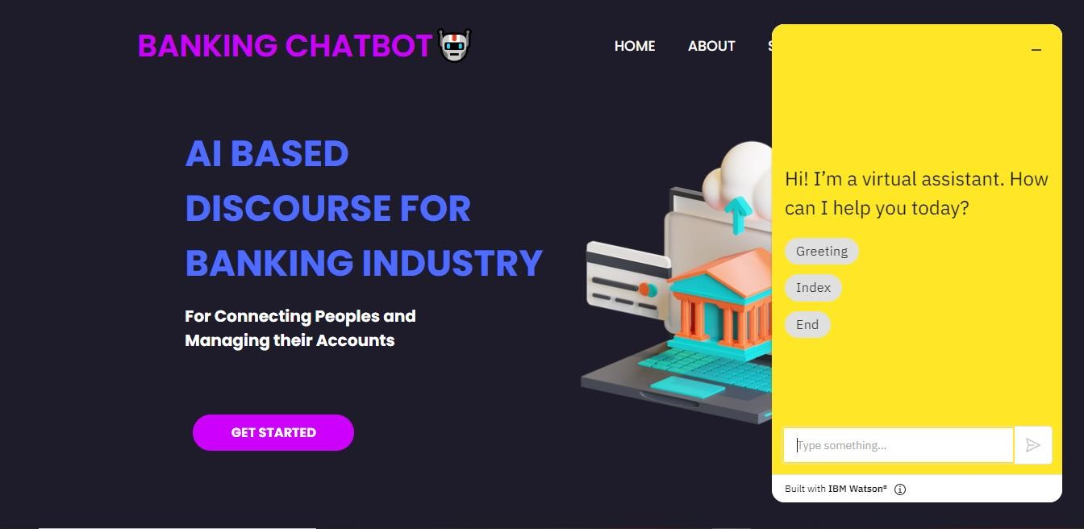

**Note:** No code for this project. So, I attached the screenshot and step to build

it.